**Community pattern analyses in R**

Today, we will compute some of the community patterns seen in class for data on alien plant species in Pacific islands, to explore how alien plant communities are structured. To do so, you will need to install and load the three following packages:

tidyverse – this will be used to reformat the data to be able to compute the patterns

vegan – this will be used to compute different community patterns

betapart – this will be used to compute patterns of beta diversity

We will use the PaciFlora database: <https://datadryad.org/stash/dataset/doi:10.5061/dryad.qfttdz0hd>

PaciFlora is a comprehensive, accessible database containing the distribution of naturalised vascular plant species in the Pacific (i.e. introduced species). The Pacific Region has the highest density of naturalised plant species worldwide, which makes it an important area for research on the ecology, evolution and biogeography of biological invasions. During this practical, we will explore patterns of plant invasions across different groups of islands in the Pacific, and see if there are similarities and differences.

We will examine patterns for the Society archipelago in French Polynesia (14 islands), the Marquesas archipelago (10 islands), also in French Polynesia, but more remote and closer to the equator, the Hawaiian archipelago (13 islands), with bigger islands, the Fiji archipelago (49 islands), with many more islands, and the Samoa archipelago (12 islands, two big ones and 10 much smaller around). These archipelagos therefore have different levels of remoteness, spatial scales, population size, and are in different hemispheres, which all could influence how much they are invaded by plants. Take a moment to make a list of how invasions may be influenced by these factors, and make some hypothesis about which archipelagos should be more invaded than others.

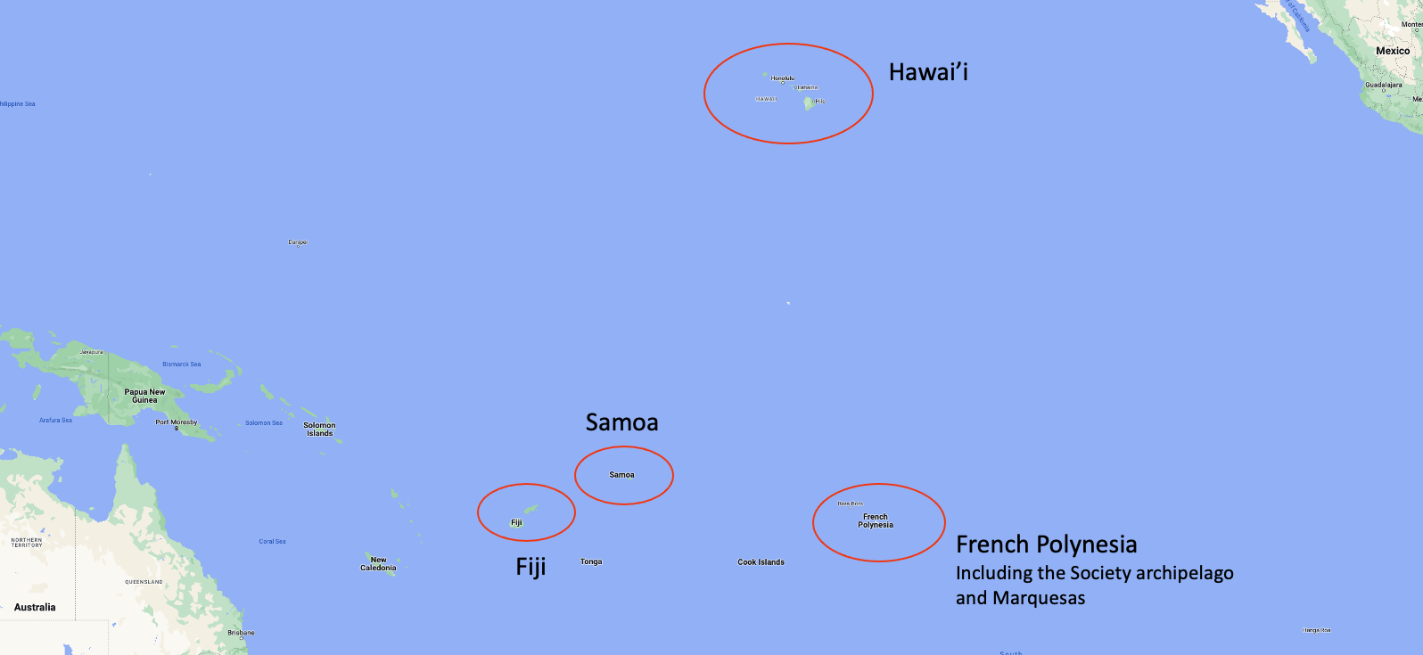

**Figure.** Map of the different archipelagos.

Society:

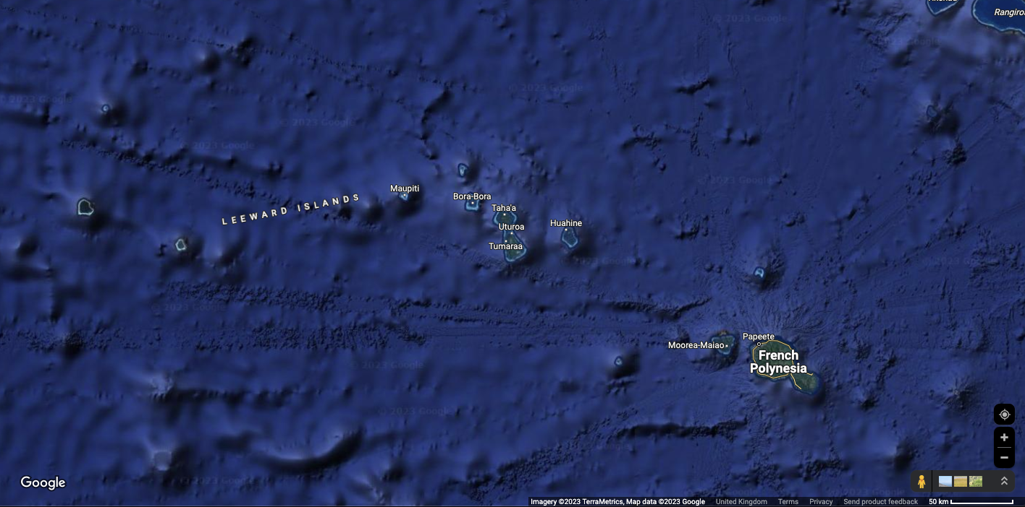 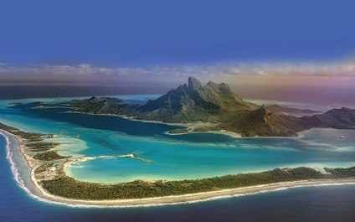

Marquesas:

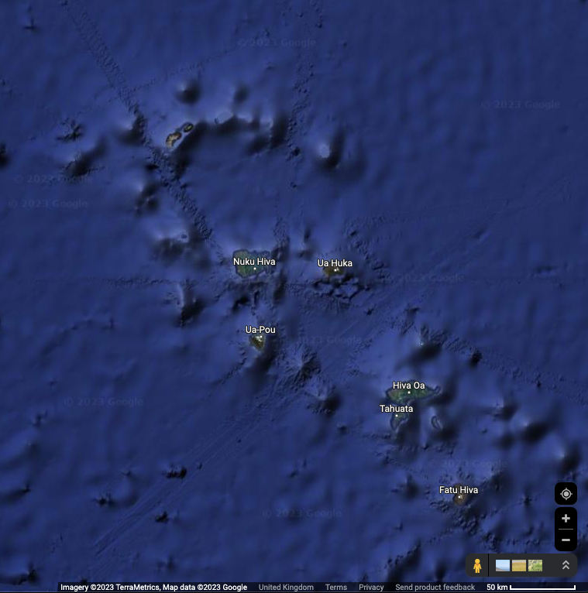 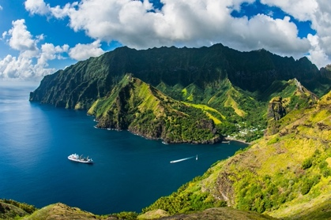

Hawai’i:

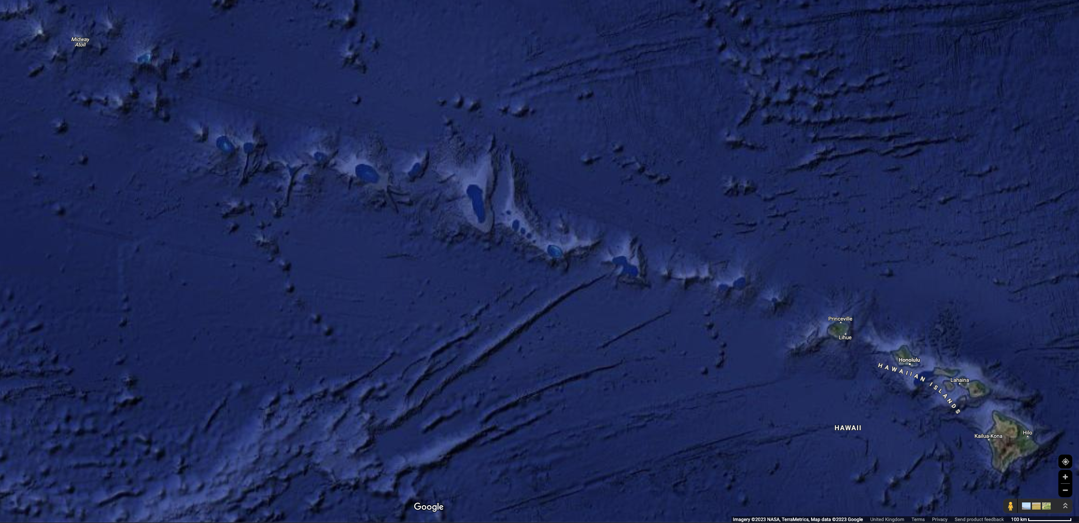 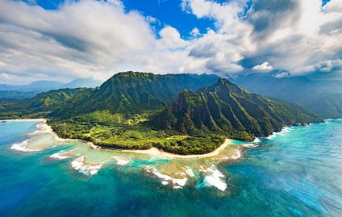

Fiji:

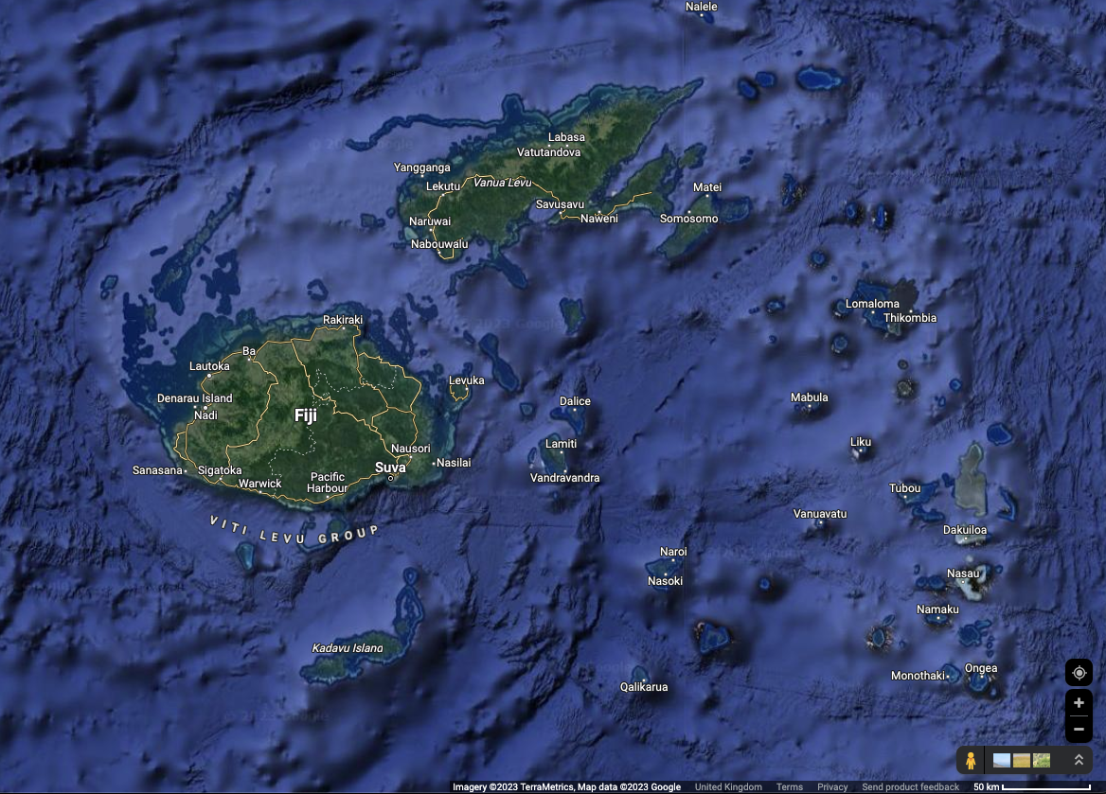 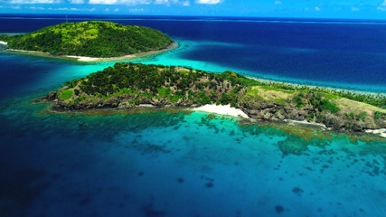

Samoa:

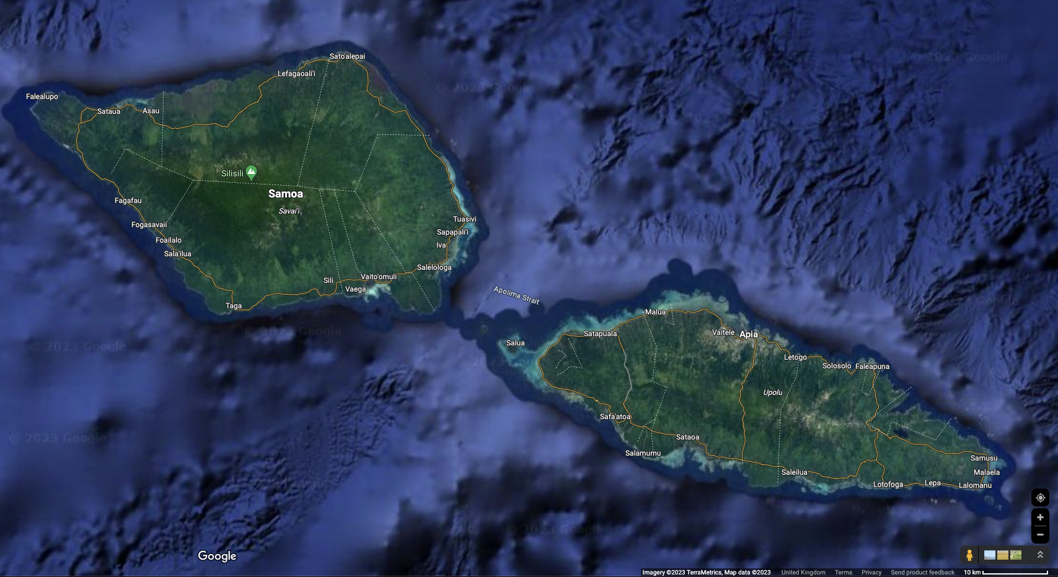 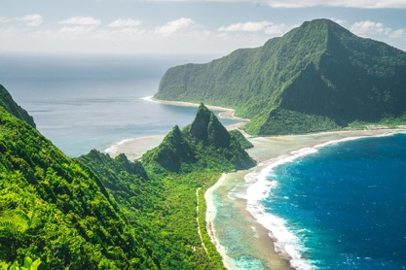

**Load the database and format the data**

Download the database using the link above and import the data from the file “Species_list_full_2905.csv” in R using the read.csv() function. Store your data in a data frame called dat.all. Note that this data frame is in a “tidy” format, i.e. each row represents a unique combination of site and species, with additional information about these two elements. **Make sure you remove rows with NA’s for species or islands.** You can do so by removing the row numbers identified with the following code:

which(is.na(dat.all$species)) ##which species have NA’s

which(is.na(dat.all$island)) ##which islands have NA’s

During the database practical in Professional Skills, we saw that one should assess if the data is “clean”, i.e. if the species names are all accepted based on some reference and do not contain multiple synonym species. But for this practical, we will keep it simple and overlook this aspect, so we will just use the raw data.

Create 6 data frames from dat.all:

* dat.soc will contain data for islands belonging to the Society archipelago in French Polynesia: only keep the rows corresponding to the indices identified calling which(dat.all$islandgroup=="Society")
* dat.mar will contain data for islands belonging to the Marquesas archipelago also in French Polynesia: only keep the rows corresponding to the indices identified calling which(dat.all$islandgroup=="Marquesas")
* dat.haw will contain data for islands belonging to the Hawaiian archipelago: only keep the rows corresponding to the indices identified calling which(dat.all$islandgroup=="Hawaiian")
* dat.sam will contain data for islands belonging to the Samoa archipelago: only keep the rows corresponding to the indices identified calling which(dat.all$islandgroup=="Samoa")
* dat.fij will contain data for islands belonging to the Fiji archipelago: only keep the rows corresponding to the indices identified calling which(dat.all$islandgroup=="Fiji")
* dat.comb will combine the five data frames above (we will use this one a bit later)

To compute community patterns, we will need site-by-species data frames. We need to create these data frames as follows, one for each tidy data frame:

* create temporary data frames with 3 columns: one for islands, one for species, and an extra one filled with 1’s to represent presences
* use the function pivot_wider()
* replace NA’s by 0’s
* rename the rows with the island names stored in the first column
* delete the first column

This can be done with the code below for the Society archipelago:

dat.soc.red <- dat.soc[,c("species","island")]

dat.soc.red$presence <- 1

dat.soc.pa <- dat.soc.red %>%

pivot_wider(names_from=species,values_from=c(presence))

list0 <- as.list(rep(0,ncol(dat.soc.pa)))

names(list0) <- names(dat.soc.pa)

dat.soc.pa <- as.data.frame(dat.soc.pa %>% replace_na(list0))

row.names(dat.soc.pa) <- dat.soc.pa$island

dat.soc.pa <- dat.soc.pa[,-1]

Adapt this code for the other archipelagos.

**Richness patterns**

Compute gamma (γ) and alpha (α) diversity for each archipelago from the species-by-site data frames. This can be done with one line of code for each metric. Which is the most invaded archipelago? Does it correspond to your hypotheses?

**Species accumulation curves**

Species accumulation curves (SAC) capture how diversity changes in space. We will start computing SACs for the observed data. Look at the documentation for function specaccum() in the vegan package, and use this function to compute and plot the SACs. Are these SACs saturating? Can we conclude if the data is close to containing all alien species present in these archipelagos?

As we saw in class, the Chao2 estimator allows to examine the species pool by estimating how many species we have missed by sampling specific sites in a whole area. Look at the documentation for function poolaccum() in the vegan package, and use this function to compute and plot the SACs estimated with the Chao2 estimator.

Compute the ratio between the estimated and observed γ diversity for each archipelago.

Can we conclude that we have missed species?

**Beta diversity**

We will now examine how alien species are distributed across islands within each archipelago. To do so, we will compute beta (β) diversity indices using the betapart package.

Look at the documentation for function betapair() in the betapart package, and use this function to compute pairwise β diversity indices between all islands within archipelagos. Do this also for the combined data.

Function betapair() provides three β diversity indices. Compute the mean for each of them and for each archipelago. What do the results tell you about how similar the alien plant composition of islands is within the different archipelagos?

We will use a metric dimensional scaling approach to plot the islands on a 2D plot based on the dissimilarity between them, using the combined data. Let’s call the output of the betapair() function beta.comb. Function cmdscale() performs a principal coordinate analyses (PCoA), to plot the data in 2D so that the distances between all islands in 2D best approaches the dissimilarity measure.

Let’s perform the PCoA and plot the output, for the Simpson and Sorensen indices:

coord.comb.sim <- data.frame(cmdscale(beta.comb$beta.sim))

coord.comb.sim$col <- c(rep("blue",nrow(dat.soc.pa)),rep("red",nrow(dat.haw.pa)),rep("darkgreen",nrow(dat.sam.pa)),rep("orange",nrow(dat.mar.pa)),rep("purple",nrow(dat.fij.pa)))

coord.comb.sim$pch <- c(rep(0,nrow(dat.soc.pa)),rep(1,nrow(dat.haw.pa)),rep(2,nrow(dat.sam.pa)),rep(3,nrow(dat.mar.pa)),rep(4,nrow(dat.fij.pa)))

coord.comb.sor <- data.frame(cmdscale(beta.comb$beta.sor))

coord.comb.sor$col <- c(rep("blue",nrow(dat.soc.pa)),rep("red",nrow(dat.haw.pa)),rep("darkgreen",nrow(dat.sam.pa)),rep("orange",nrow(dat.mar.pa)),rep("purple",nrow(dat.fij.pa)))

coord.comb.sor$pch <- c(rep(0,nrow(dat.soc.pa)),rep(1,nrow(dat.haw.pa)),rep(2,nrow(dat.sam.pa)),rep(3,nrow(dat.mar.pa)),rep(4,nrow(dat.fij.pa)))

par(mfrow=c(1,3))

plot(coord.comb.sim$X1,coord.comb.sim$X2,col=coord.comb.sim$col,pch=coord.comb.sim$pch,lwd=2,main="Simpson")

plot(coord.comb.sor$X1,coord.comb.sor$X2,col=coord.comb.sor$col,pch=coord.comb.sor$pch,lwd=2,main="Sorensen")

plot.new()

legend(x="topleft",legend=c("Society","Hawai’i","Samoa","Marquesas","Fiji"),col = c("blue","red","darkgreen","orange","purple"),pch=0:4,lwd=2,bty="n",lty=0,cex=2)

Visually, how do you interpret these two graphs? Are islands more similar to each other within or between archipelagos? Do both indices generate similar results? Look at the location of these five archipelagos on Google Maps. Does it suggest why you observe these results?

**Occupancy-frequency distributions (OFD)**

For each archipelago, compute the occupancy of each species relative to the total number of islands. For each archipelago, you should obtain one vector with one value in [0,1] for each island.

Plot the OFDs of the five archipelagos using function hist(). What similarities or differences between archipelagos do these distributions indicate?

**Global perspective**

Based on all these patterns combined together, can you provide a short summary of how alien plant species are distributed across Pacific islands for these five archipelagos?